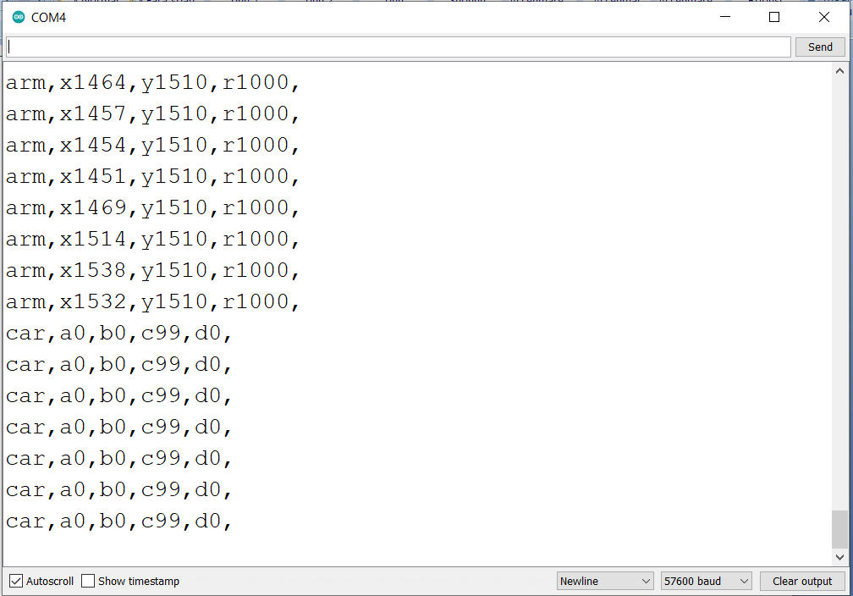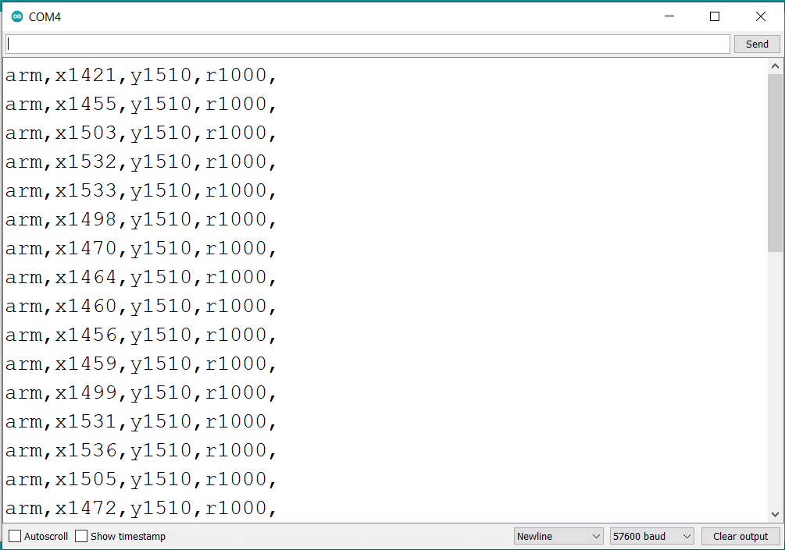

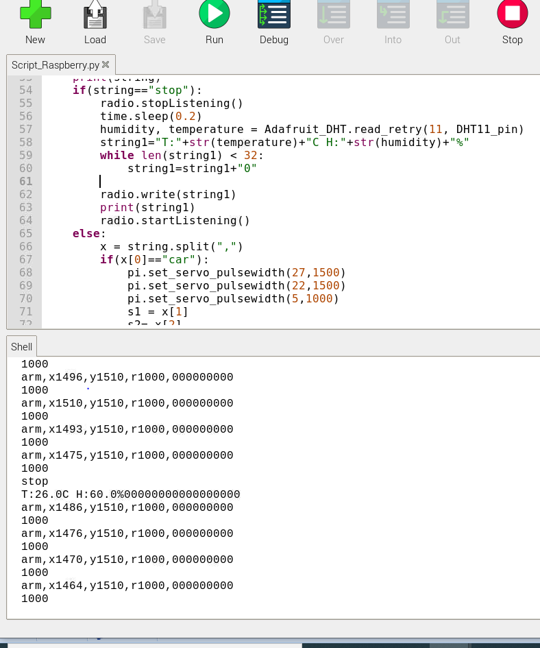

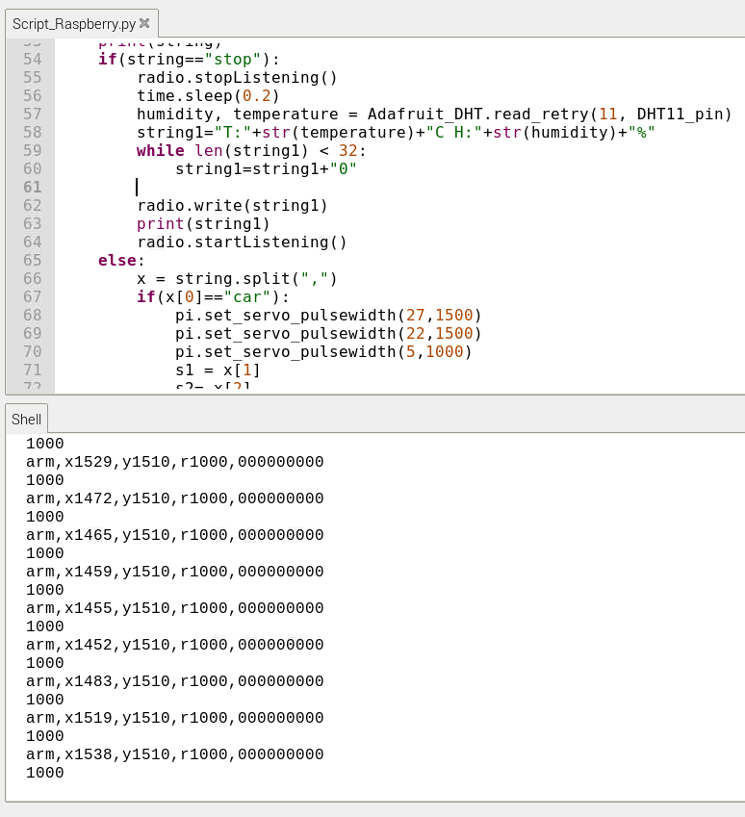

#include <RF24.h>

#include<SPI.h>

#include<DigitalIO.h>

#include <LiquidCrystal_I2C.h>

#include <Wire.h>

LiquidCrystal_I2C lcd(0x27,16,2);

RF24 radio(9,10);

const uint64_t add=0xF0F0F0F0E1LL;

const uint64_t add1=0xE7E7E7E7E7LL;

//ce = 9, csn = 10 pins

int16_t value_x=0,value_y=0,value_sw = 0, value_x1 = 0, value_y1 = 0, value_sw1 = 0;;

const int buttonPin = 4;

int buttonState ;

int buttonState_sw ;

void setup() {

Serial.begin(57600);

SPI.begin();

pinMode(A6, INPUT);

pinMode(A7, INPUT);

pinMode(A0, INPUT);

pinMode(A1, INPUT);

pinMode(2, INPUT_PULLUP);

pinMode(8, INPUT_PULLUP);

pinMode(buttonPin, INPUT_PULLUP);

digitalWrite(buttonState, HIGH);

radio.begin();

radio.setPALevel(RF24_PA_MIN);

radio.setChannel(0x76);

radio.setDataRate(RF24_1MBPS);

radio.setAutoAck(false);

//radio.printDetails();

radio.openWritingPipe(add) ;

radio.openReadingPipe(1,add1);

radio.enableDynamicPayloads();

radio.powerUp();

lcd.init();

lcd.backlight();

lcd.setCursor(0,0); }

void loop() {

radio.stopListening();

float pos = 1000;

delay(100);

value_x = analogRead(A6);

value_y = analogRead(A7);

value_sw1 = digitalRead(2);

value_x1 = analogRead(A0);

value_y1 = analogRead(A1);

String text,s1,s2,s3,s4,a1,a2,a3;

buttonState = digitalRead(buttonPin);

buttonState_sw = digitalRead(2);

if(buttonState==HIGH){

if(value_x>470 && value_x<550 && value_y>470 && value_y<550)

{a1="x"+String(int(value_x1+pos))+",";

a2="y"+String(int(value_y1+pos))+",";

if(buttonState_sw==LOW)

a3="b"+String(1500)+",";

else

a3="r"+String(1000)+",";

text="arm,"+a1+a2+a3;

char mesaj[32];

text.toCharArray(mesaj,32);

Serial.println(mesaj);

radio.write(&mesaj, sizeof(mesaj));

delay(500); }

else {

if(value_x<470){

s3="c0";

s4="d"+String(int(abs(value_x-470)/4.71));

}else if(value_x>550) {

s3="c"+String(int((value_x-550)/4.74));

s4="d0";

}else{

s3="c0";

s4="d0"; }

if(value_y<470){

s1="a0";

s2="b"+String(int(abs(value_y-470)/4.71));

}else if(value_y>550){

s1="a"+String(int((value_y-550)/4.74));

s2="b0";

}else{

s1="a0";

s2="b0"; }

text="car,"+s1+","+s2+","+s3+","+s4+",";

char mesaj[32];

text.toCharArray(mesaj,32);

Serial.println(mesaj);

radio.write(&mesaj, sizeof(mesaj));

delay(500); }}else{

char a[32]="stop";

radio.write(&a, sizeof(a));

delay(200);

radio.startListening();

delay(200);

if(radio.available()){

while(radio.available()){

char text1[32]={0};

radio.read(&text1, sizeof(text1));

//String copie(text);

Serial.println(text1);

lcd.clear();

lcd.print(text1);

radio.stopListening(); } }

delay(500);

}}